WEEK 7 — DevOps & IaC Basics

Author: Amrish Kumar
Date: November 2025
Lab Deliverable — Week 7

1. Objectives (Week 7 Scope Only)
• Deploy Azure Static Website using Terraform
• Use GitHub Actions to automate Terraform executions
• Apply tags for governance and cost tracking
• Follow Git/GitHub workflow (branch → commit → push → pipeline)
• Understand provider, variables, outputs, state
• Research Terraform vs Bicep

2. Repository Structure
terraform-azure-static-site/
│
├── main.tf
├── provider.tf
├── variables.tf
├── terraform.tfvars
├── output.tf
│
├── index.html
│
└── .github/workflows/deploy.yml

3. Steps Performed
• Configured Azure Cloud Shell and Git.
• Created Terraform files for Azure Resource Group + Storage Account.
• Created index.html to be hosted via Azure Static Website.
• Initialized Terraform using `terraform init`.
• Validated infrastructure using `terraform plan`.
• Deployed infrastructure using `terraform apply`.
• Verified Azure Static Website endpoint.
• Created GitHub repository and pushed Terraform code.
• Configured GitHub Secrets for Azure authentication.
• Configured GitHub Actions workflow for CI/CD.
• Verified automatic pipeline execution on push to main.
• Added tags for governance and cost tracking.

4. Required Screenshots (Insert Below)

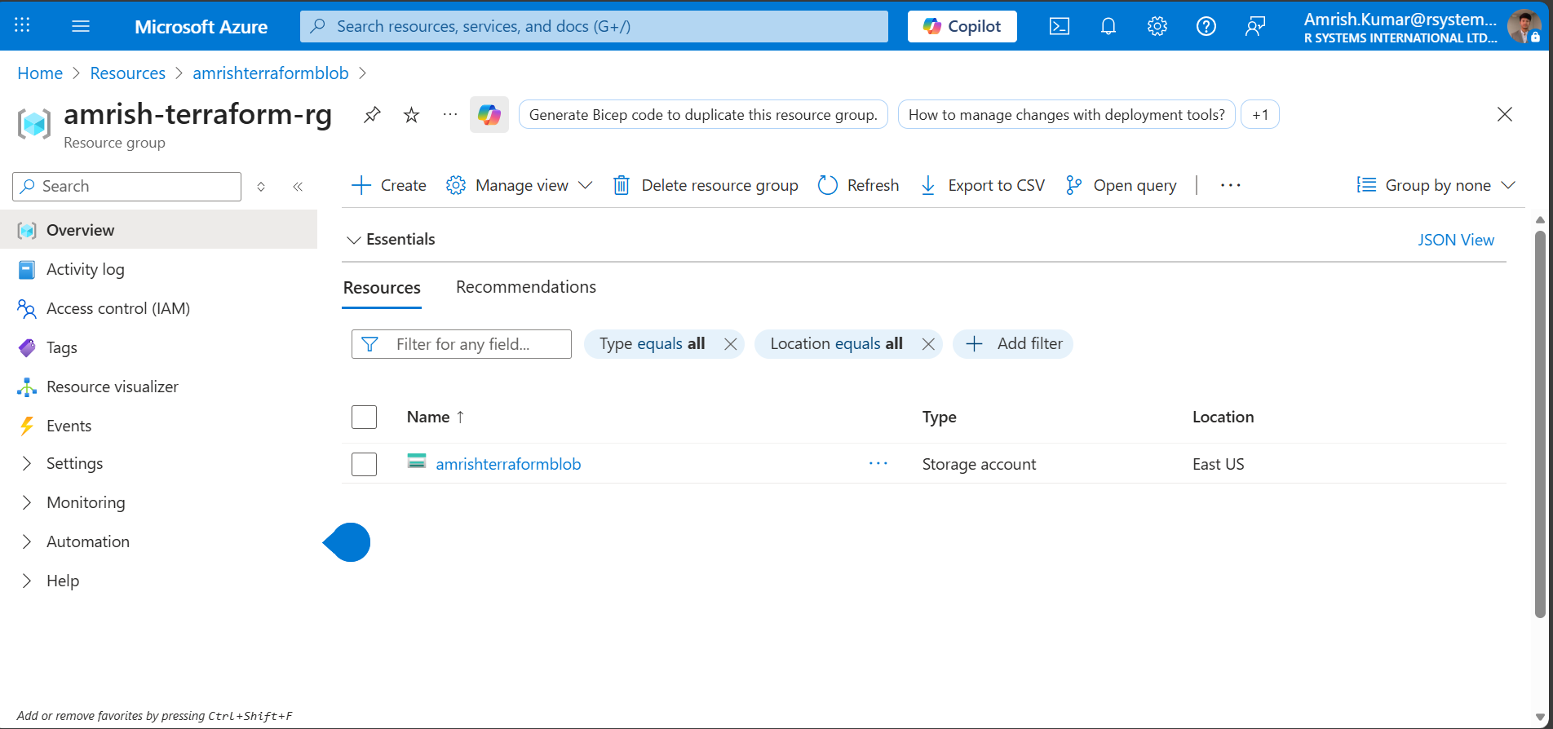
Screenshot 1: Azure Resource Group containing Terraform resources

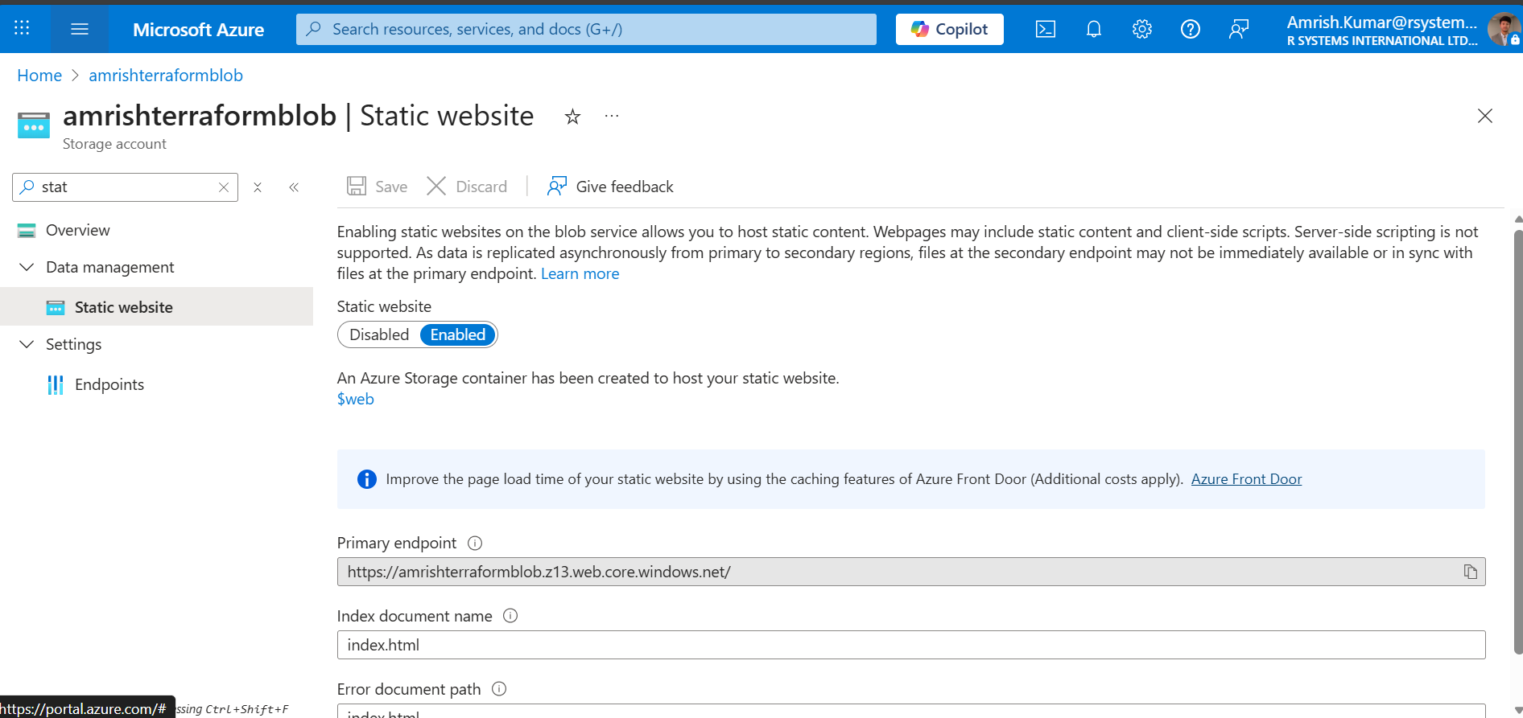
Screenshot 2: Azure Storage Account with Static Website enabled
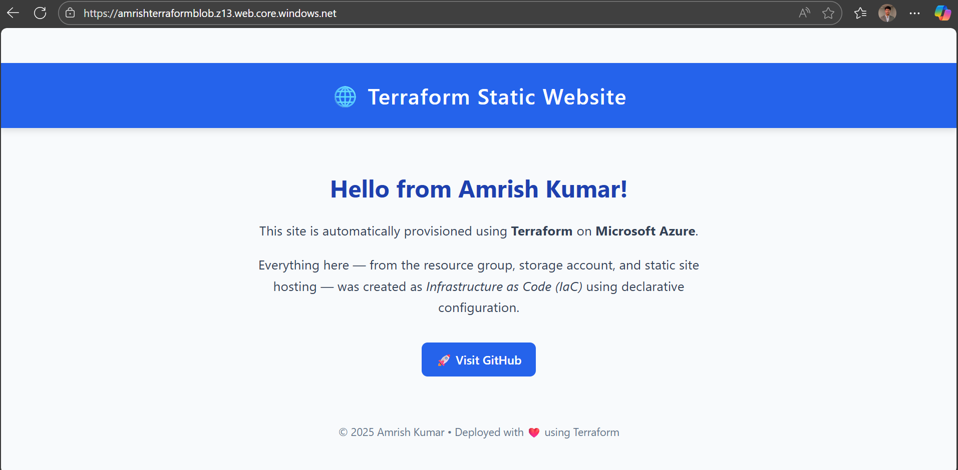
Screenshot 3: Static Website URL opened in browser
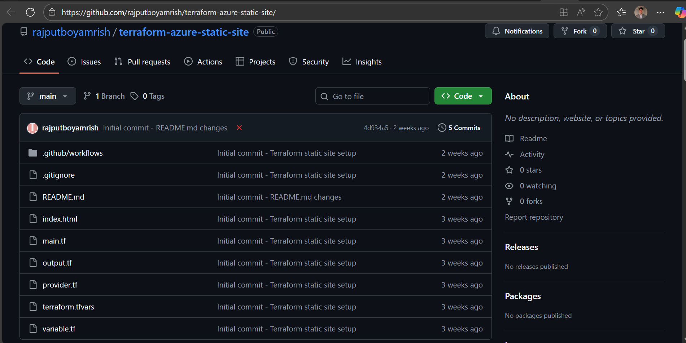
Screenshot 5: GitHub repository structure view

5. Terraform vs Bicep (Research Summary)
Terraform:
• Multi-cloud support
• Strong module ecosystem
• Uses remote/local state
• Best for enterprise and multi-cloud IaC
Bicep:
• Azure-native
• Simpler syntax
• No external state file
• Best for Azure-only lightweight deployments
Conclusion:
Terraform = scalable + multi-cloud
Bicep = Azure-focused simplicity

6. Deliverables Summary (Week 7)
✔ Terraform Code (Resource Group + Storage + Static Website)
✔ GitHub Actions Workflow YAML
✔ Resource tagging for governance
✔ Successful CI/CD pipeline run
✔ Terraform vs Bicep research included
✔ Week 7 filtered DOCX deliverable (this document)

